16SW180
 |  | Department of Software Engineering
 | Mehran University of Engineering and Technology, Jamshoro
 | Course: SWE324 - Data Warehousing and Data Mining
Instructor | Rabeea Jaffari | Practical/Lab No. | 09
Date | 1st Aug 2018 | CLOs | CLO-4: P3 & P4
Signature |  | Assessment Score | 1 Marks
Topic | To become familiar with ETL process
Objectives | - To learn ETL process for DWHs using Integration Services.

Lab Discussion: Theoretical concepts and Procedural steps

Lab Tasks

Submission Date: 08-08-18

TASK : Lab1 dealt with extracted data from a single flat file source, transformed the data using Lookup transformations, and finally loaded the data into

the FactCurrency fact table of the AdventureWorksDW2014 sample database. However, a typical ETL process would extract data from multiple flat file sources and you have to do so. The sample files can be downloaded from the link below:

https://padlet.com/rubeeajaff/m0y6wnh2ifk1

And the steps to be followed are found at the following link:

https://docs.microsoft.com/en-us/sql/integration-services/lesson-2-adding-looping-with-ssis?view=sql-server-2017
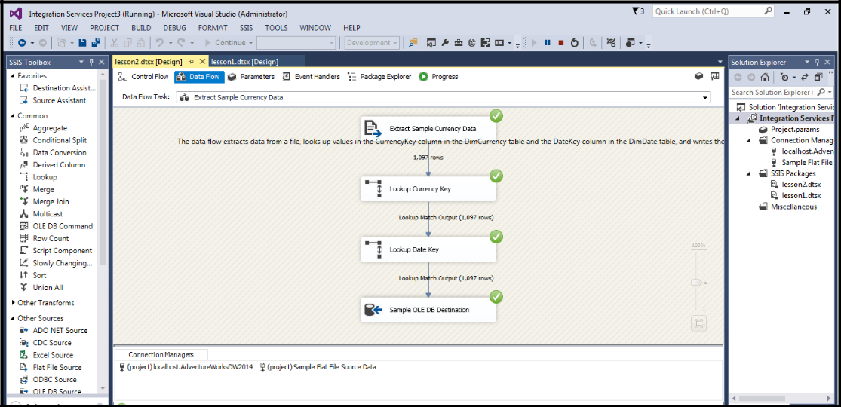
16SW180
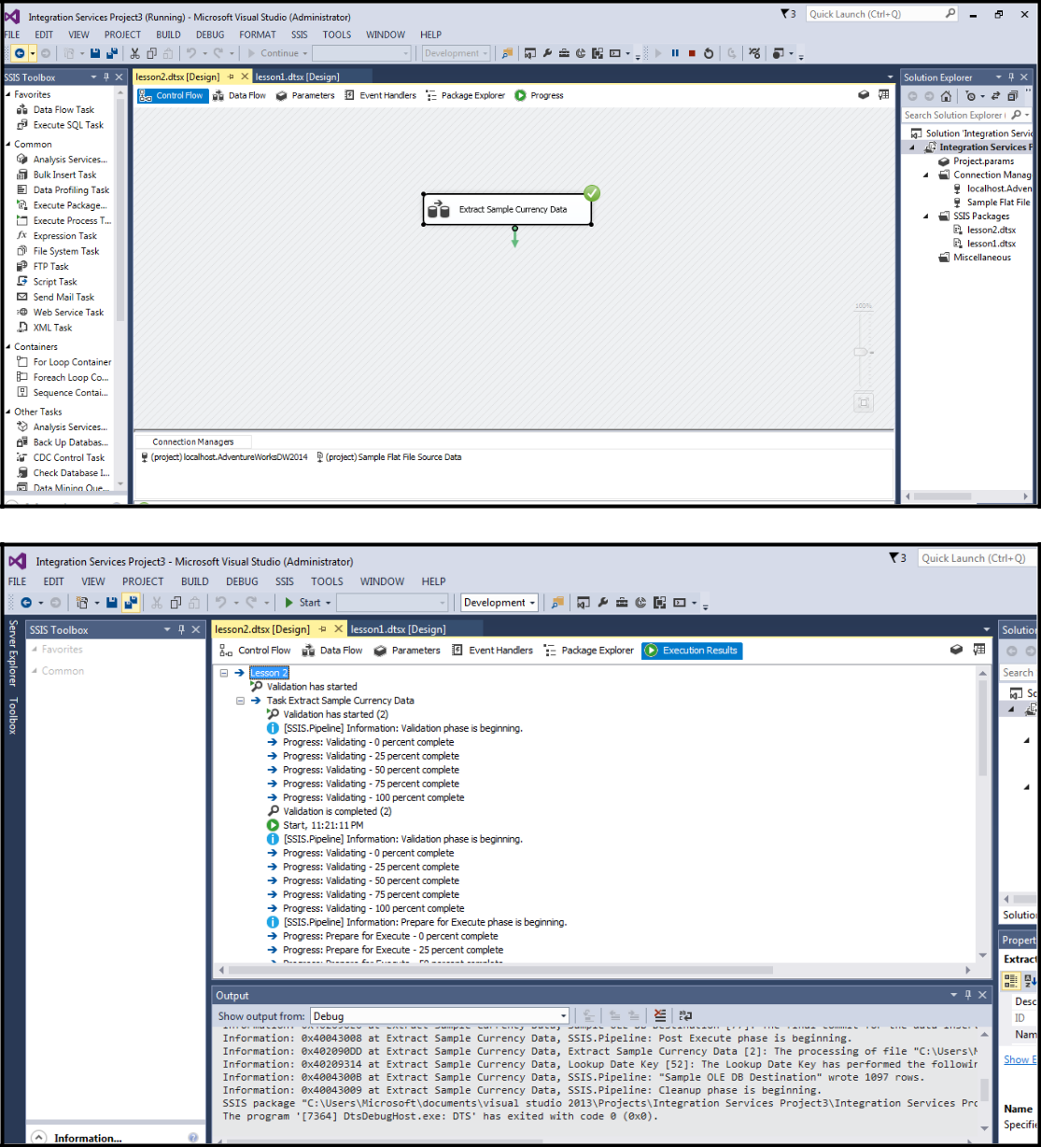
16SW180
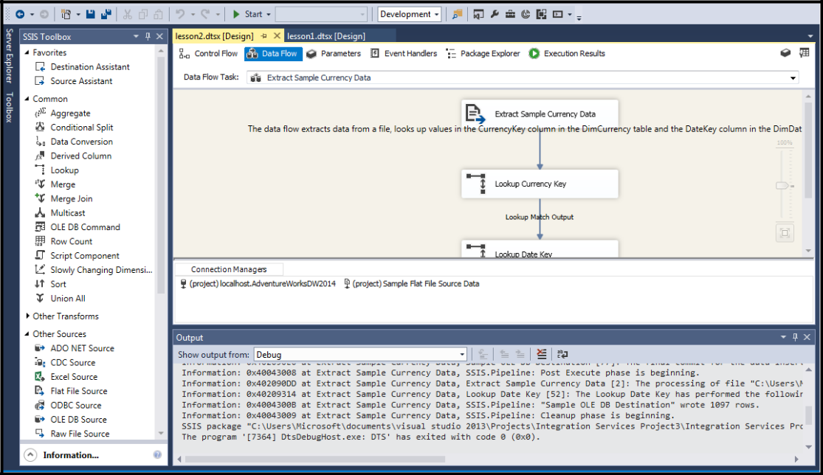

Class Task:
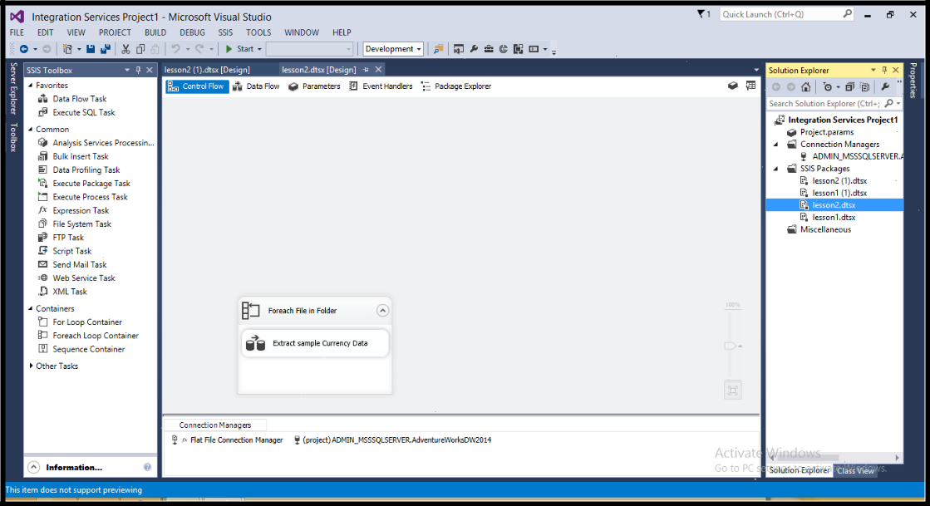
16SW180
